Practical No: 5
Practical 5: Analyze your system at a high level and prepare the following UML diagrams for your system.
a. Class Diagram
b. Use Case Diagram
c. Sequence Diagram
d. Activity Diagram
e. State Diagram

a) Class Diagram:
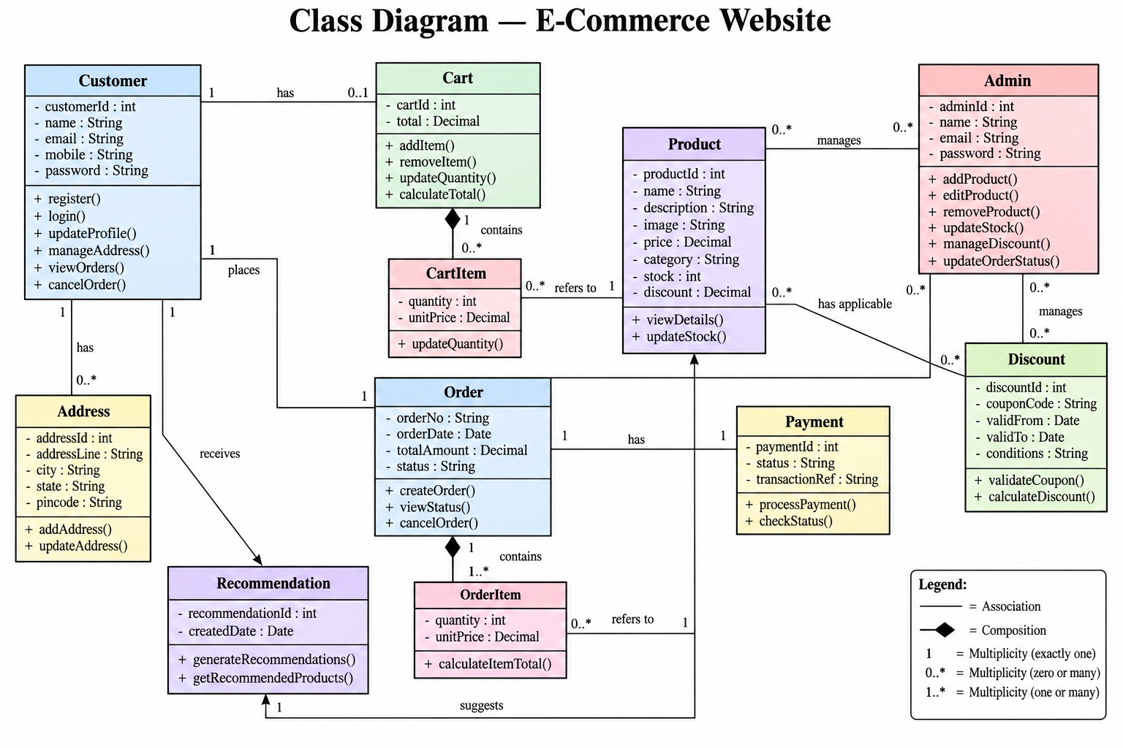

b) Use Case Diagram:
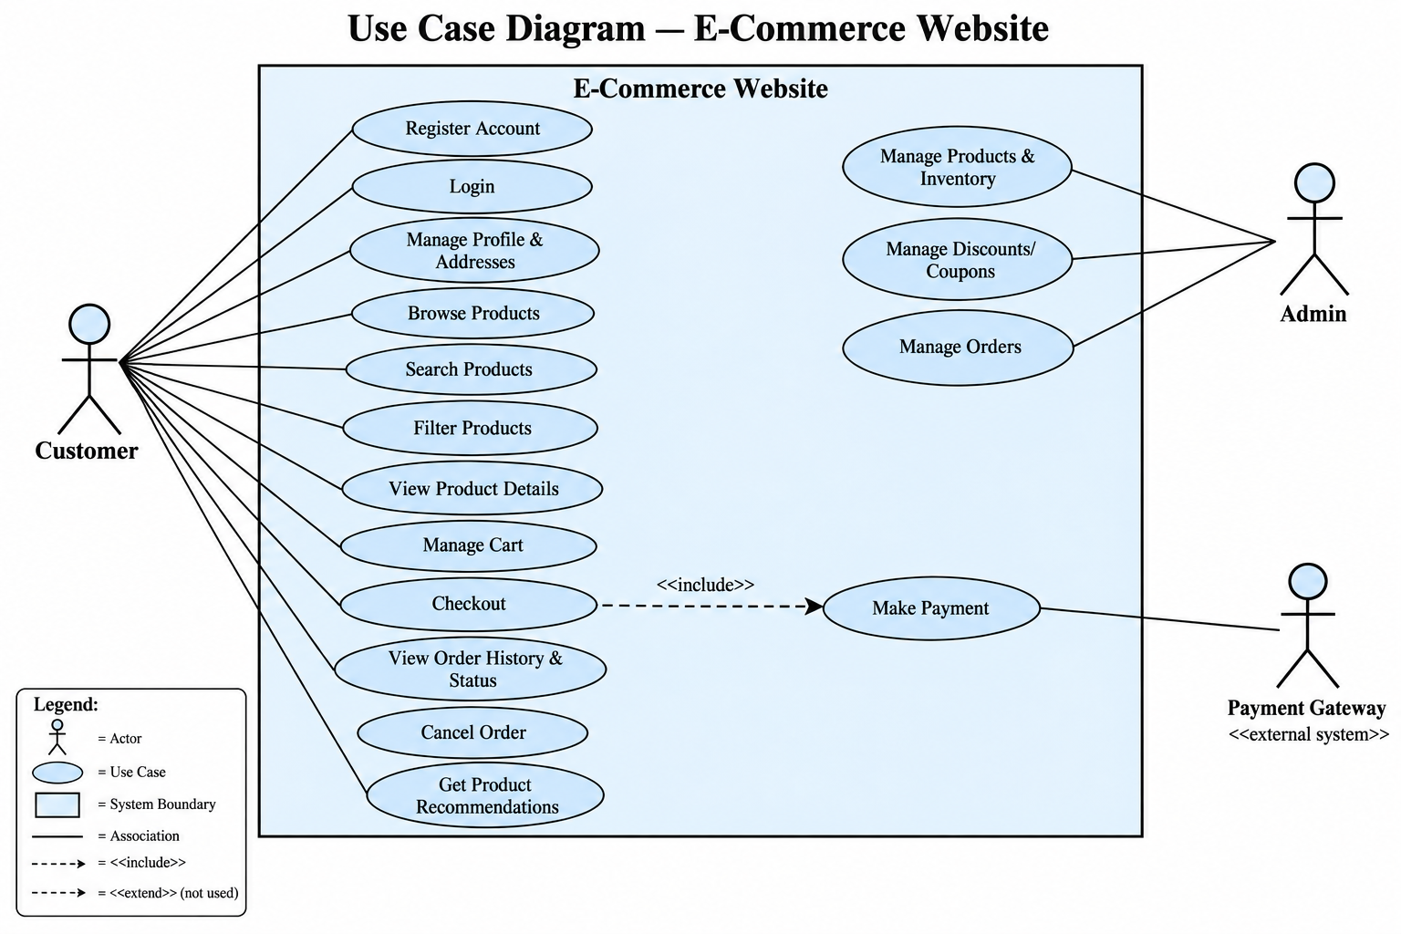

c) Sequence Diagram:
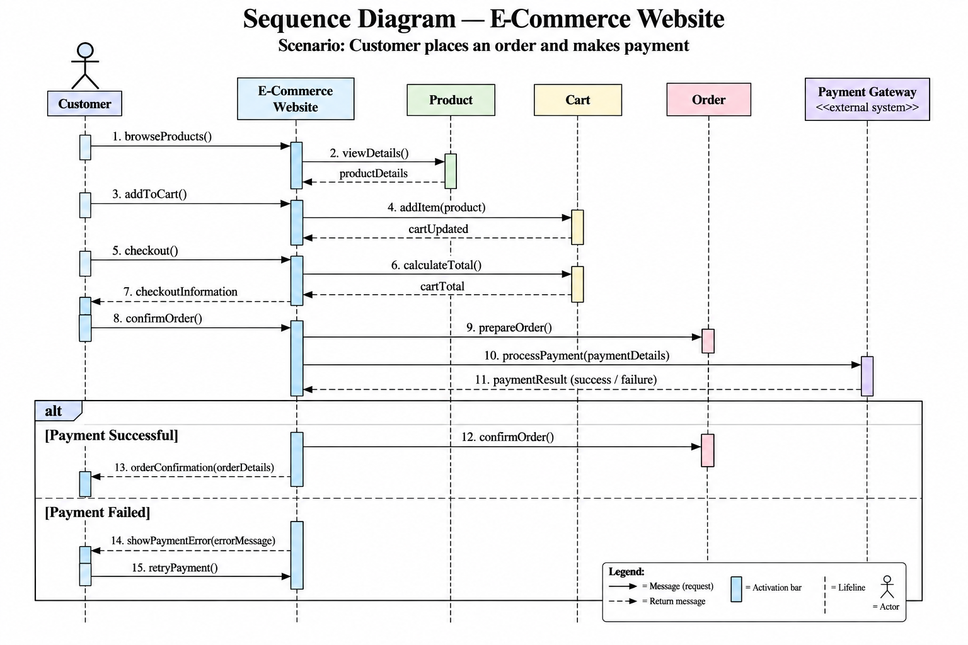

d) Activity Diagram:
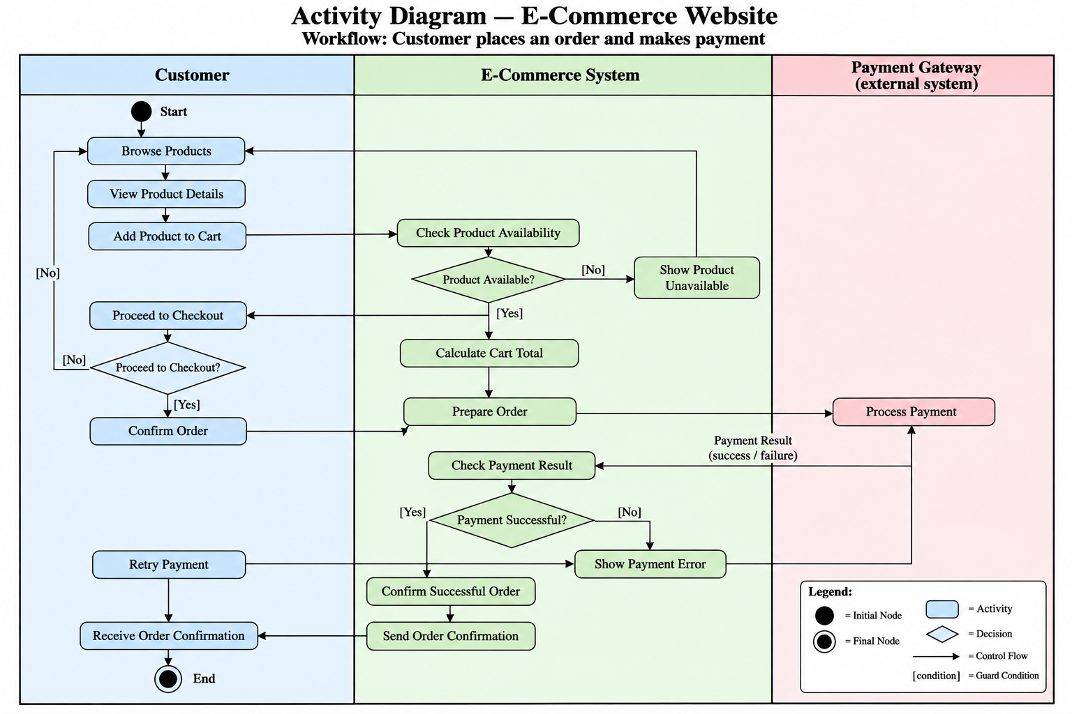

e) State Diagram:
